CPH7000: Portable, multifunctional
and ideal for on-site calibration

Klingenberg, January 2017.
The new CPH7000 process calibrator from WIKA is a portable multi-function instrument. It combines the measurement of pressure, temperature, current, voltage and ambient conditions. The CPH7000 is therefore suitable for the testing and calibration of analogue pressure measuring instruments and also pressure and process transmitters.

In the version with an integrated hand pump for test pressures from
-0.85 … +25 bar, an integrated barometer and an external atmospheric module, the CPH7000 enables an on-site calibration with only one instrument. With its electronic module, the calibrator can supply all standard measuring devices with current and voltage, measure output signals, simulate sensor conditions and carry out pressure switch tests. Furthermore, via a Pt100 probe, it can even measure the medium temperature.

Working with an accuracy of 0.025% of measuring span, the CPH7000 is easy to operate. A touchscreen with eight application fields enables a speedy and safe setting of the functions and parameterisation of all tasks. A high-performance data logger automatically saves all measured values. These can be transmitted via the WIKA-Wireless function to a final device with the WIKA-Cal software for further processing. In addition, with WIKA-Cal the creation and upload of calibration routines to the CPH7000 is possible.

Number of characters: 1342
Key word: CPH7000

Manufacturer:
WIKA Alexander Wiegand SE & Co. KG
Alexander-Wiegand-Straße 30
63911 Klingenberg/Germany
Tel. +49 9372 132-0
Fax +49 9372 132-406
vertrieb@wika.com
www.wika.de

WIKA company photograph:
Process calibrator CPH7000

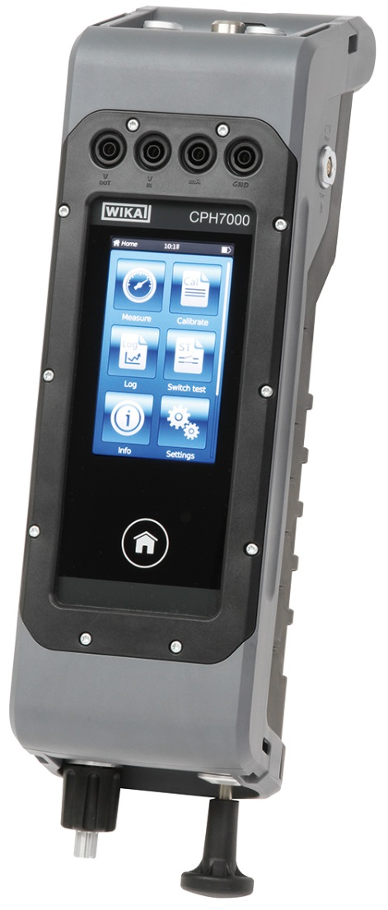

Edited by:
WIKA Alexander Wiegand SE & Co. KG
André Habel Nunes
Marketing Services
Alexander-Wiegand-Straße 30
63911 Klingenberg/Germany
Tel. +49 9372 132-8010
Fax +49 9372 132-8008010
andre.habel-nunes@wika.com
www.wika.de

WIKA press release 02/2017

