Monoblock for sampling and injection processes

Klingenberg, February 2020.- Two new WIKA monoblocks with probes support the control and regulation of media properties within pipelines. The model IBS3 has been developed for sampling, the model IBJ4 for injection procedures.

The compact monoblocks can be delivered with needle valves and/or ball valves in double-block-and-bleed configuration. The valve arrangement depends on the application and the same applies to the length and material of the probe. With the model IBJ, a non-return valve is also integrated which prevents bi-directional flow during the injection process.

The manufacturing of the two instrumentation valves enables smooth and precise operation of the valves with low torque. Monoblocks with ball valves also have a redundant polymere-metal sealing system with a tested leak tightness in accordance with BS6755 / ISO 5208 leak rate A.

Number of characters: 827
Key word: Monoblock IBS/IBJ

Manufacturer:
WIKA Alexander Wiegand SE & Co. KG
Alexander-Wiegand-Straße 30
63911 Klingenberg/Germany
Tel. +49 9372 132-5049
Fax +49 9372 132-406
vertrieb@wika.com
www.wika.de

WIKA company photograph:
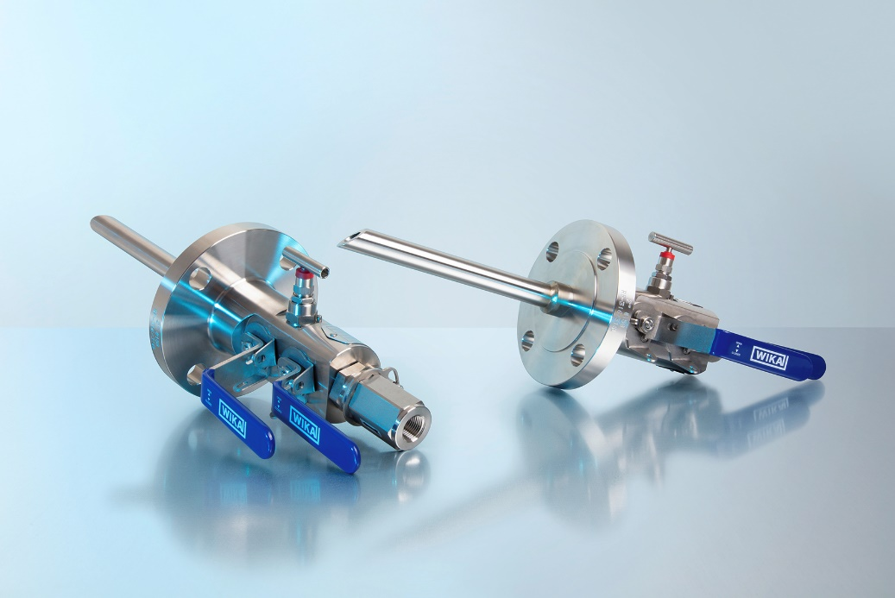
Monoblock Typen IBS3, IBJ4

Edited by:
WIKA Alexander Wiegand SE & Co. KG
André Habel Nunes
Marketing Services
Alexander-Wiegand-Straße 30
63911 Klingenberg/Germany
Tel. +49 9372 132-8010
andre.habel-nunes@wika.com
www.wika.de

WIKA press release

