Adhesive label set for
red-green marking

Klingenberg, February 2019
An individual red-green marking on pressure gauges and dial thermometers is now also possible using an adhesive label. WIKA offers a corresponding set of arcs for nominal sizes 63, 100 and 160.

The red and green arcs can be mounted in different lengths and positions on the window, even on already installed instruments. Thus, without any great effort, any scale range desired can be defined. When ordering small quantities of instruments, the new accessory (model designation 910.33) is a cost-effective alternative to the corresponding dial layout.

The adhesive labels have a long shelf life due to their temperature- and UV-resistant material. They are also translucent. Therefore, the dial remains easy to read.

Number of characters: 713
Key words: Red-green marking

Manufacturer:
WIKA Alexander Wiegand SE & Co. KG
Alexander-Wiegand-Straße 30
63911 Klingenberg/Germany
Tel. +49 9372 132-5049
Fax +49 9372 132-406
vertrieb@wika.com
www.wika.de

WIKA company photograph:
An individual red-green marking on pressure gauges and dial thermometers is now also possible using an adhesive label

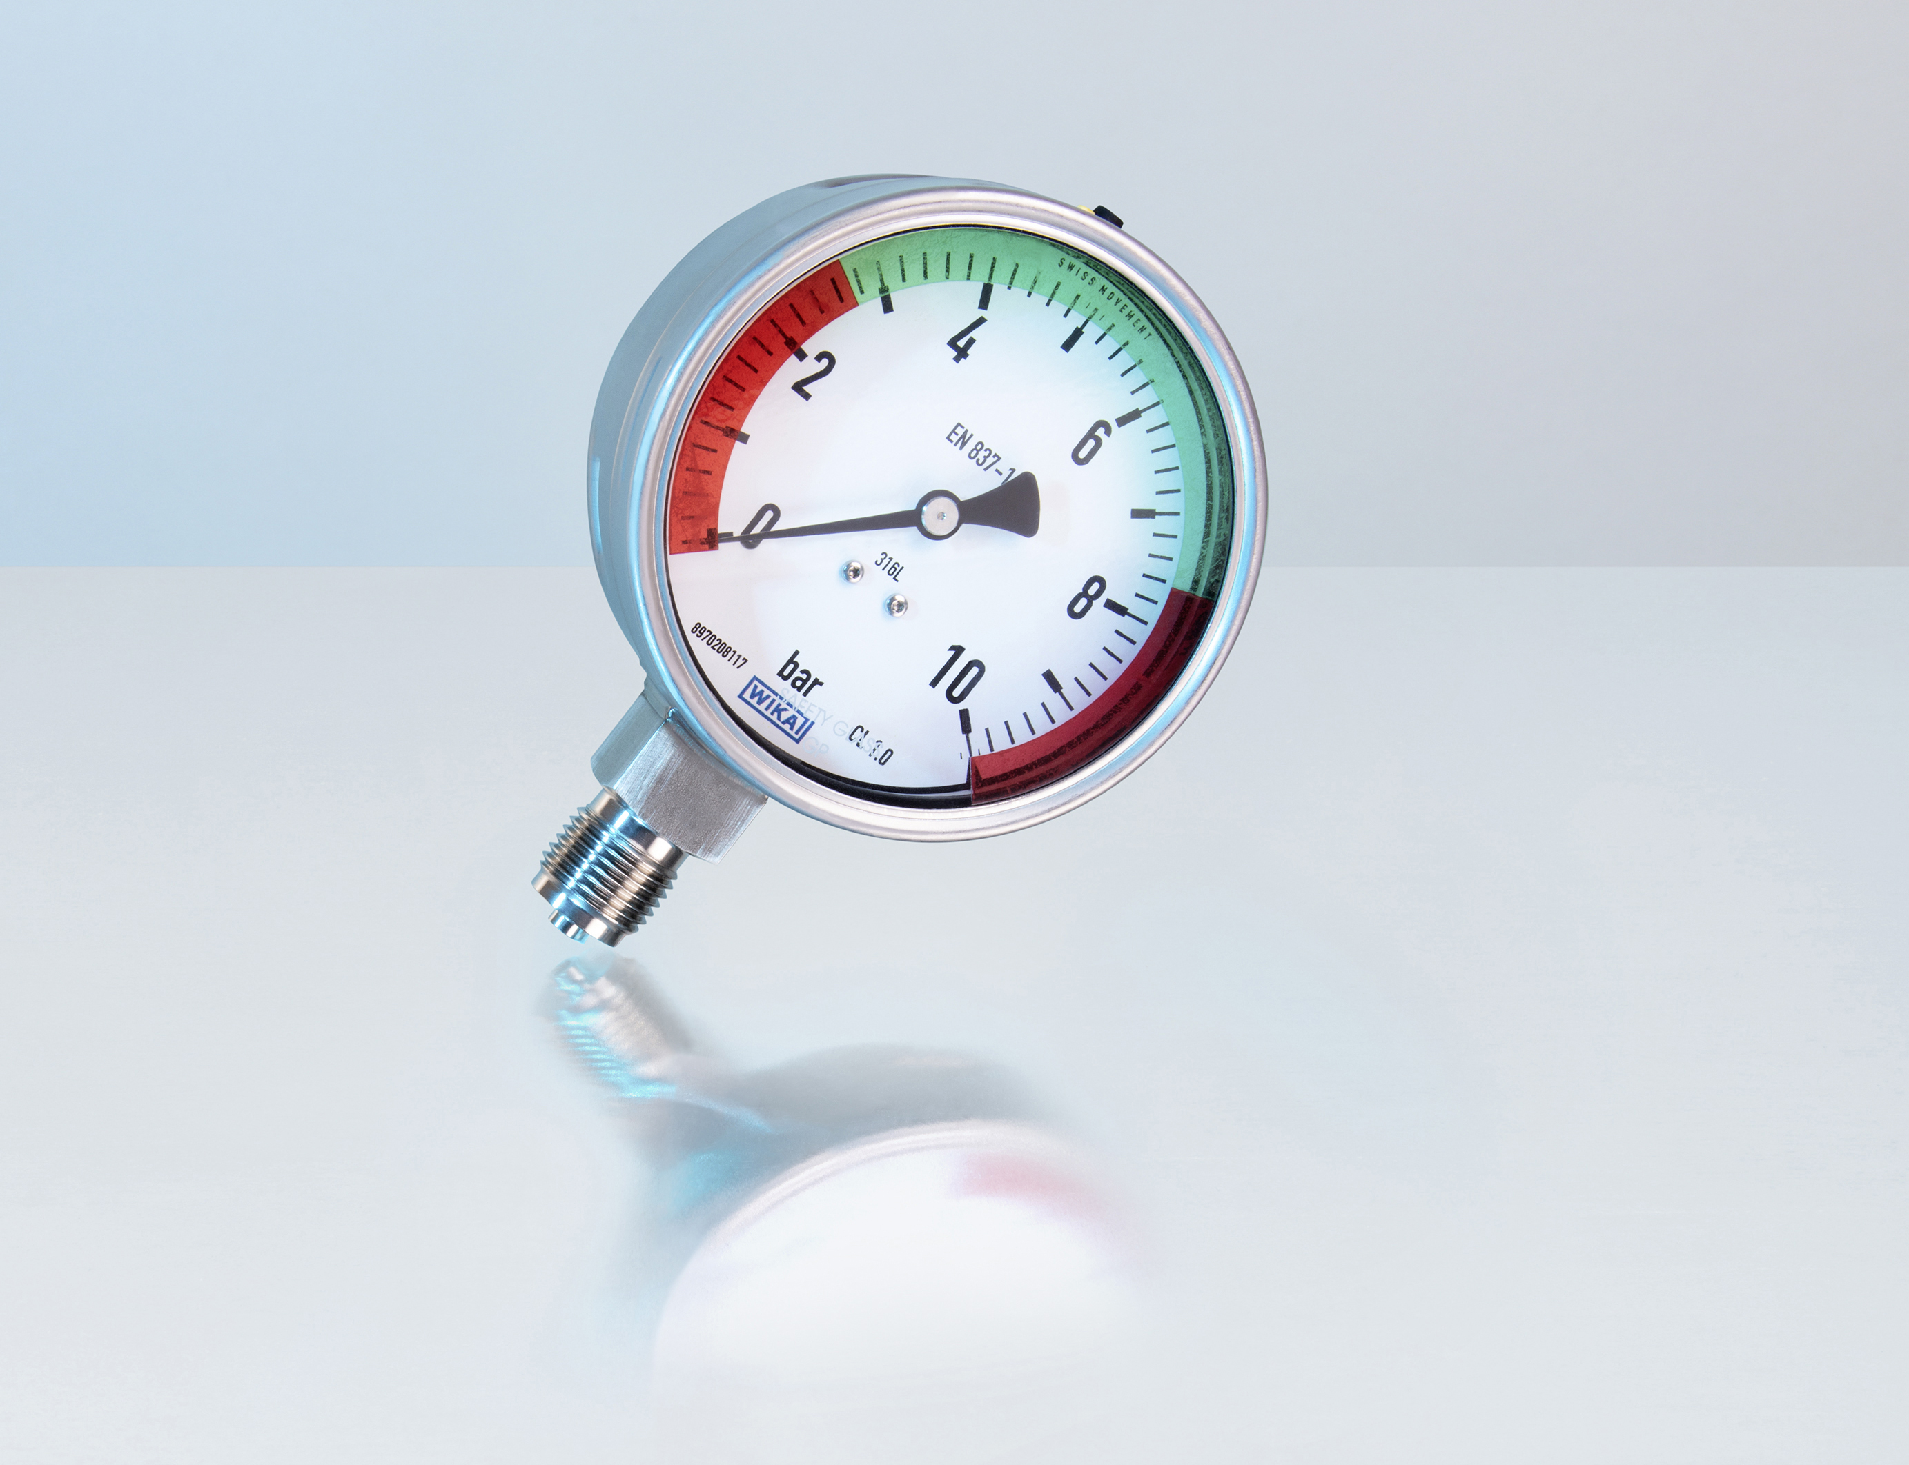

Edited by:
WIKA Alexander Wiegand SE & Co. KG
André Habel Nunes
Marketing Services
Alexander-Wiegand-Straße 30
63911 Klingenberg/Germany
Tel. +49 9372 132-8010
Fax +49 9372 132-8008010
andre.habel-nunes@wika.com
www.wika.de

WIKA press release 02/2019

