New diaphragm pressure gauge
for hygienic processes

Klingenberg, March 2016.
From hygienic case design to small process connections: WIKA has tailored its new PG43SA-S diaphragm pressure gauge to the requirements of sanitary applications.

With this, there is now also a mechanical measuring instrument available for safe pressure monitoring in hygienic applications. Its measuring principle, with a flush welded diaphragm, enables mechanical pressure transmission, whereby the risk of product contamination through a transmission fluid is eliminated. As a result of its high overpressure safety, the instrument can also withstand critical process conditions.

The operational flexibility of the PG43SA-S is supported through a large selection of small process connections − for example, to DIN 32676 (clamp) or to DIN 11864. Tested in accordance with 3-A Sanitary Standards, the pressure gauge with hygienic case is CIP, SIP and wash-down capable. It can thus be cleaned reliably and time-efficiently. An easily accessible zero adjustment on the top of the case enables calibration if needed.

Number of characters: 1012
Key word: PG43SA-S

Manufacturer:
WIKA Alexander Wiegand SE & Co. KG
Alexander-Wiegand-Straße 30
63911 Klingenberg/Germany
Tel. +49 9372 132-0
Fax +49 9372 132-406
vertrieb@wika.com
www.wika.de

WIKA company photograph:
WIKA has tailored its new PG43SA-S diaphragm pressure gauge to the requirements of sanitary applications.

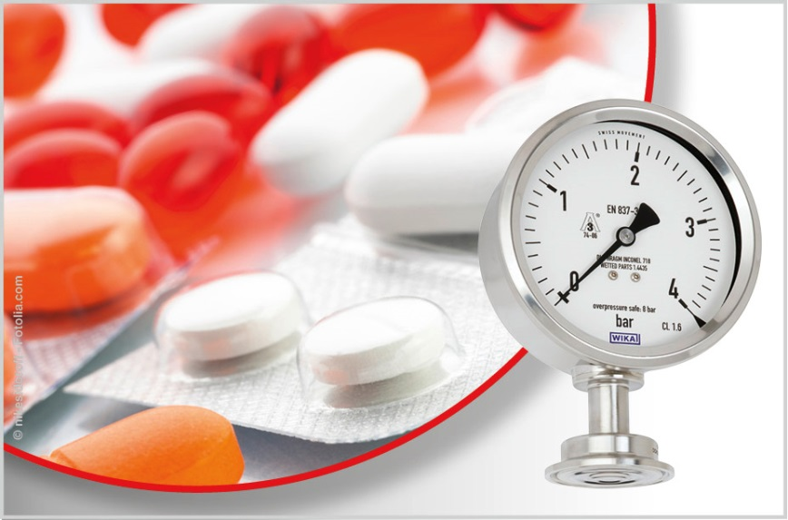

Edited by:
WIKA Alexander Wiegand SE & Co. KG
André Habel Nunes
Marketing Services
Alexander-Wiegand-Straße 30
63911 Klingenberg/Germany
Tel. +49 9372 132-8010
Fax +49 9372 132-8008010
andre.habel-nunes@wika.com
www.wika.de

WIKA press release 04/2016

