Digital temperature transmitter
now also for thermocouples
Klingenberg, July 2017.
WIKA has completed its new temperature transmitter family: With the model T16, a digital instrument is now also available exclusively for thermocouples (TC).

The new transmitter, with analogue output and high basic accuracy, is available in a head-mounted or rail-mounted version. It processes signals from all commercially available TCs. The T16 can be intuitively and quickly configured via WIKAsoft-TT software and the magWIK quick connector. Due to its additional sensor connection from outside, a large clamping range (up to 2.5 mm²) and an imprinted pin assignment, it is also easy to install.

Like its counterpart for resistance sensors, model T15, the T16 can be used in a wide variety of applications. It is certified in accordance with the DIN EN 61326-2-3:2013 EMC protection standard, has sensor-break monitoring in accordance with NAMUR recommendations and an ATEX or IECEx approval.

Number of characters: 896
Key word: T16

Manufacturer:
WIKA Alexander Wiegand SE & Co. KG
Alexander-Wiegand-Straße 30
63911 Klingenberg/Germany
Tel. +49 9372 132-0
Fax +49 9372 132-406
vertrieb@wika.com
www.wika.de

WIKA company photograph:
Temperature transmitter, model T16, in head and rail-mounted versions

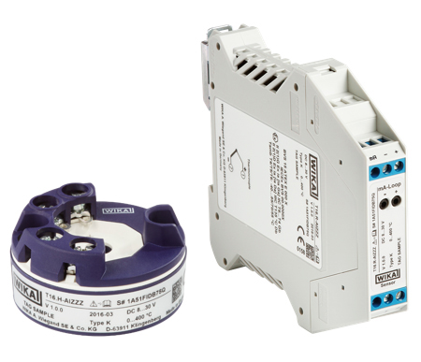

Edited by:
WIKA Alexander Wiegand SE & Co. KG
André Habel Nunes
Marketing Services
Alexander-Wiegand-Straße 30
63911 Klingenberg/Germany
Tel. +49 9372 132-8010
Fax +49 9372 132-8008010
andre.habel-nunes@wika.com
www.wika.de

WIKA press release 12/2017

