Diaphragm seal systems with process transmitters: Replacement service optimises the benefit
Klingenberg, November 2017.
Operators of diaphragm seal systems with mounted process transmitters can now take advantage of a replacement service. WIKA has put together a service package with which the long-term benefit and the overall costs of such a measuring assembly can be optimised.

Diaphragm seal systems often operate under extreme conditions. In the event of a failure of the system, however, in many cases it is enough to replace only the mounted diaphragm seal and to continue using the process transmitter. As part of the replacement service, WIKA takes the measuring system apart, checks and certifies the functionality of the process transmitter and replaces the mounted diaphragm seal with an equivalent one. Then a calibration of the new diaphragm seal system is made. If necessary, the mounting and the system fill fluid will be optimised and also new material test certificates issued.

With the replacement service, the process transmitter can be fully utilised over its entire service life. Preventive exchange of the diaphragm seal at planned shut-downs further reduces plant downtime. In order to offer this new service worldwide, and as close to customers as possible, WIKA will install service centres in the respective subsidiaries.

Number of characters: 1227
Key words: Replacement service

Manufacturer:
WIKA Alexander Wiegand SE & Co. KG
Alexander-Wiegand-Straße 30
63911 Klingenberg/Germany
Tel. +49 9372 132-0
Fax +49 9372 132-406
vertrieb@wika.com
www.wika.de
WIKA company photograph:
WIKA Flyer Replacement service for diaphragm seal systems with process transmitters

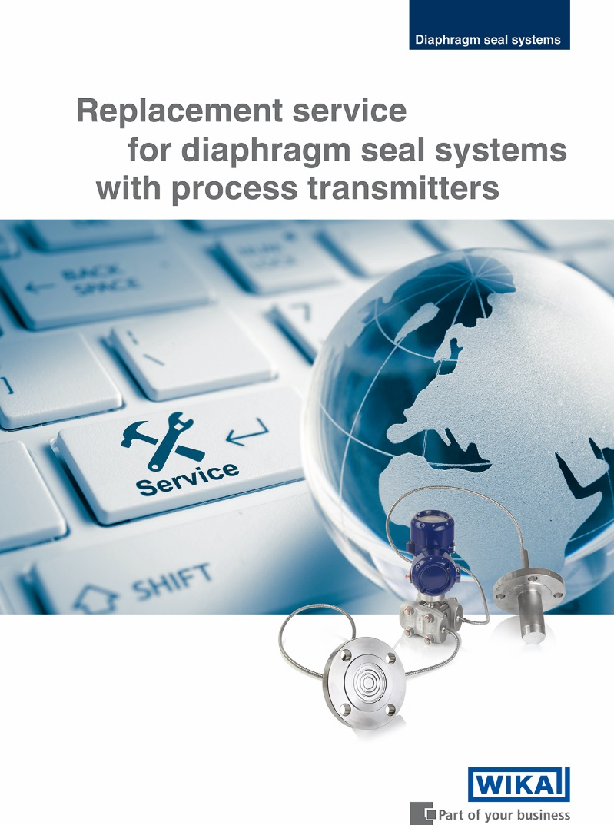

Edited by:
WIKA Alexander Wiegand SE & Co. KG
André Habel Nunes
Marketing Services
Alexander-Wiegand-Straße 30
63911 Klingenberg/Germany
Tel. +49 9372 132-8010
Fax +49 9372 132-8008010
andre.habel-nunes@wika.com
www.wika.de

WIKA press release 15/2017

